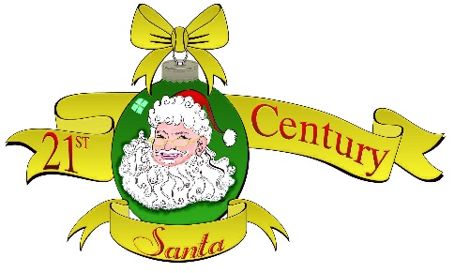
21st Century Santa, Inc.
1225 Hwy 37, Minco, OK. 73059
(580) 301-4538/4539
director@21centurysanta.com
CANDY CANE CLASSICS
CAR/TRUCK/MOTORCYCLE SHOW

BILL JOHNSON PARK
MINCO, OKLAHOMA
SATURDAY, NOVEMBER 3, 2018
8:00 A.M. – 4:00 P.M.

REGISTRATION: 8-11AM, JUDGING: 11AM-1PM,
PRESENTATIONS: 2PM

All proceeds go to the mission of Non-Profit: 21st Century Santa, Inc.

Lots of Door Prizes, Food, and Entertainment. Unique Trophies.
50/50 JACKPOT. Best cars and motorcycles in Oklahoma.
EARLY REGISTRATION $25.00 by 27 OCTOBER.
LATE REGISTRATION (After 27 October) $30.00.
Make Checks Payable To: 21st Century Santa, Inc.
Mail To: 21st Century Santa, Inc. 1225 Hwy 37, Minco, OK. 73059.
For Information Call: Santa 580-301-4538 or 4539.

TOY DRIVE
Please consider donating an unwrapped toy for a child at Christmas.

__________________________________________________________________
REGISTRATION FORM

NAME: _______________________ ADDRESS: _________________________
PHONE: _________________________ EMAIL: _________________________
YEAR: ______________________ MAKE: _____________________
MODEL: __________________ CLASS: _______________________

Release Form:
I understand that by signing this form, I release 21st Century Santa Inc., its board members and volunteers, the show sponsors, and the City of Minco, OK from all claims, damages, and injuries whatsoever that may be suffered by entrant, his or her family, persons or property.

Signature: ____________________________ Date: _____________________
If entrant is under 21 a parent or guardian must sign this form.

EARLY REGISTRATION $25.00 by 27 OCTOBER.
LATE REGISTRATION (After 27 October) $30.00.
Make Checks Payable To: 21st Century Santa, Inc.
Mail To: 21st Century Santa, Inc. 1225 Hwy 37, Minco, OK. 73059.
For Information Call: 580-301-4538 or 4539.

