17 June 2017  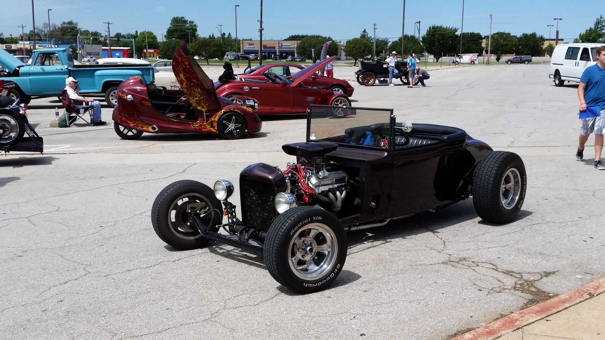  2nd Annual Moore High SCHool Band  car & bike show  Cars, Trucks, 4X4’s, and Bikes  Show us your ride and support the Moore High School Band. All modes of transport are welcome. 15 Different categories. $25 fee for each entry. Early entry is $20 before May 15th. Vendor Booth $40. Show at the Moore High School South Parking Lot. For more info e-mail moorebandcarshow@gmail.com | FREE Admission to the Public  Raffles  Door Prizes  50/50 Raffle  Food Trucks  Kona Ice  1st Place Awarded in each Class  Come Out & Share the Fun and support the MHS Band  ────  Moore High School Band Boosters  Moore High School  300 N. Eastern Ave.  Moore, OK. 73160  P.O.C Roger Burk Ph# 405-630-9472  17 June 2017  9AM – 1PM