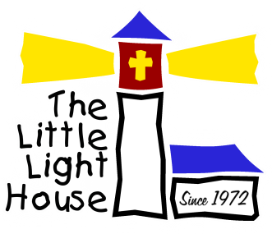
7th Annual Little Light House
People’s Choice Car & Truck Show and Shine Benefiting the children of the Little Light House
When: 9 AM–1 PM, Oct 21, 2017 (Rain or Shine)–Registration open till 11:00 Trophies at 12:30
Where: Jim Glover Chevy on the River, 707 W 51st Street…I-44 & the Arkansas River (NEW LOCATION)
Entry Fee: $20 per entrant (No checks please)-First 75 Cars get a Free Food Ticket
Benefits: The children of The Little Light House of Tulsa, www.littlelighthouse.org
16 Classes: Cars: 1939 & Older, '40-'59, '60-'79, '80-'99, 2000 & Newer; Mustangs, Corvettes,
Camaros, Jeeps
Trucks: 1949 & Older, '50-'69, '70-'89, '90 & Newer
Customs: Street Rod, Rat Rod, Kids' Class
Trophies: Top 3 in each class, plus Best of Show, Best Paint, Best Interior, Best Engine and sponsor's choice trophies
Door Prizes: Various Door Prize Items
Sponsored by: Jim Glover Auto Family - Jim Glover Chevrolet, Jim Glover on the River, Jim Glover Nissan and coming soon Jim Glover Chrysler/Dodge/Jeep/Ram/Fiat
www.jimglover.com
J. David Jewelry, 613 N. Aspen Ave, Broken Arrow or 8200 East 101st St Ste B, Tulsa
www.jdavidjewelry.com

================================================================================
Entry Fee: $20.00 donation
Car Class: ____________________ Car Number: _____________
Vehicle Year: ___________________ Make: __________________ Model: _________________
Name: ____________________________________________________
Address: __________________________________________________
City: __________________________ State: _____ Zip: _____________
Email: _____________________________________________________
Liability: In consideration of the acceptance of the right to participate, entrants, participants and spectators, by execution of the entry form, release and discharge Jim Glover Auto Family, Little Light House, Inc, J. David Jewelry and of their related entities or anyone else connected with the management and presentation of the Little Light House Show & Shine Car & Truck Show from any and all known and unknown damages, injuries, losses, judgments and/or claims from any cause whatsoever that may be suffered by an entrant to his person or property.

Signature: ___________________________________________

