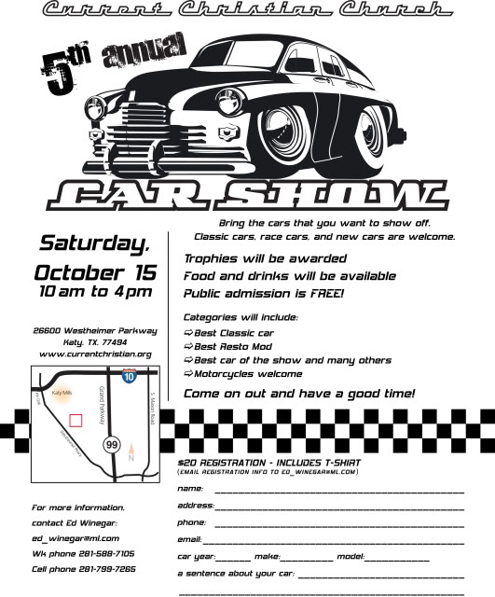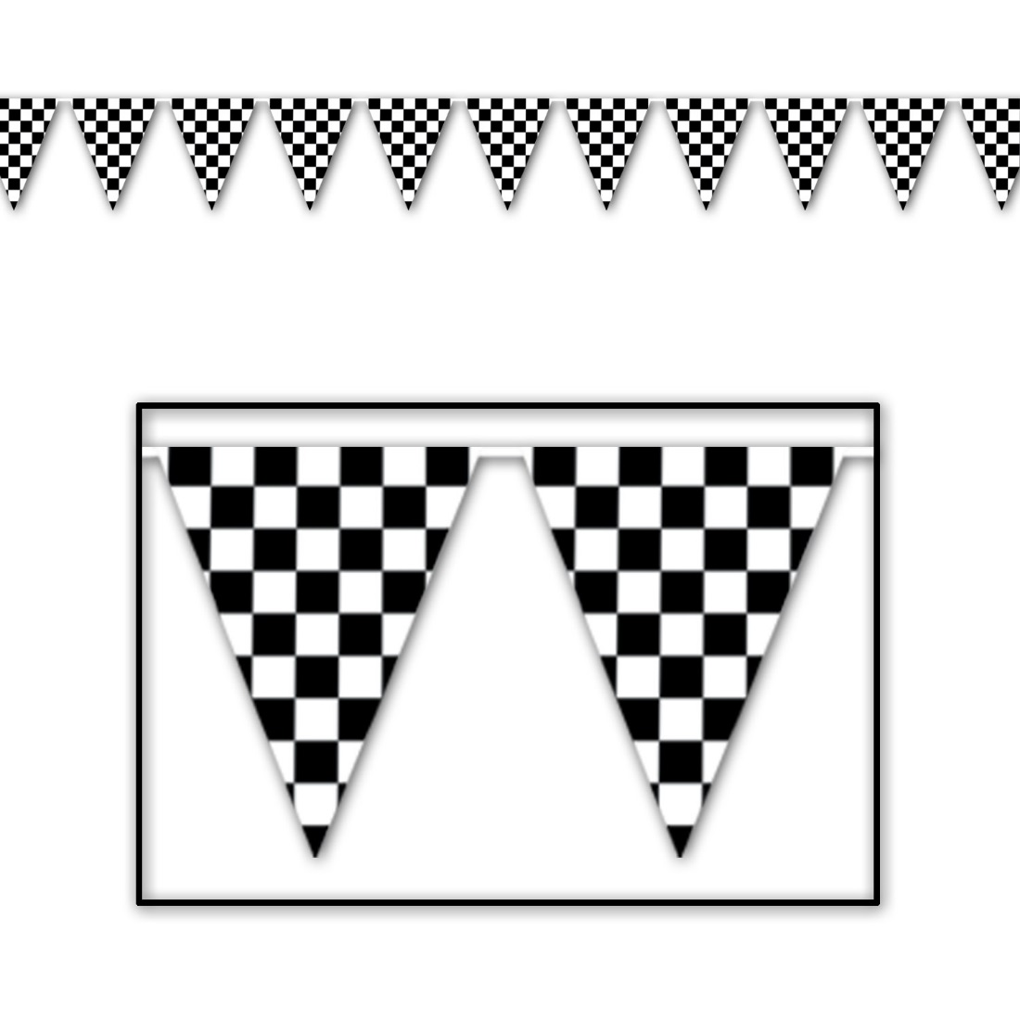

Food, Concessions, and Entertainment!

Contact Information:

First Baptist Church Langley

P.O. BOX 202

Langley, OK 74350

918-782-2673 fbclangley@yahoo.com

**Trophies for Top 40 vehicles will be awarded.**

**Special Awards Include:**

Best of Show Veteran’s Choice

People’s Choice

Minister’s Choice

**Best of Categories Include:** Ford, Mopar, GM, Import, Truck, Bike, Original and Modified

Grand Lake Fall Classic

Car, Truck and Bike Show

At Pensacola Dam

Beautiful Cherokee State Park - Lakeside

Disney, OK

Incomparable fall foliage on the shore of Grand Lake!

**All makes, trucks and motorcycles are welcome!**

All proceeds benefit the First Baptist Church of Langley Building Fund.

Saturday

October 7, 2017

$20 Registration

Registration 8-10

Judging begins at 11