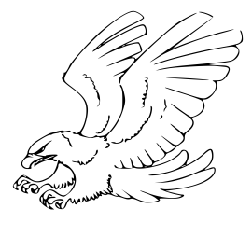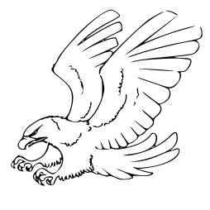

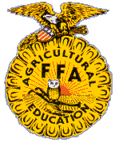

Bicycle Show

Best Dress 5 &Under

6 -11

12-15 yrs.

Cash Prizes

Car Show

5 Categories

Cash & Trophy Prizes

$100.00 Drawing!!

Saturday, October 7th

Event begins at 10:00am

a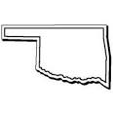

B.A.C.A.

Fingerprinting/Tattoos

Picture with Big Foot

National Guard Climbing Wall Bounce House

*Lunch!!*

11:30am-1:30pm

Adults $3.00

10 & Under $2.00

PROCEEDS WILL BE

DONATED TO AFTON SHOOL

TEACHERS FOR ROOM SUPPLIES

***Music***

***Live Entertainment***

*Live Stomp Dance*

*Free Drawing*

*Every 30 Minutes!!!*

Tractor Show

Cash Prizes

Corn Hole

Tournament!!

Adults -13 & up!

Youth -5-12yrs!

Cash Prizes!

Call 918-326-5343

*Afton Area Chamber Commerce*

Karaoke!

Youth-18-13

-6-12

-3-5

Cash Prizes!

Cake Walk

Balloon Man!

Pony Rides

Wagon Rides

Cow Paddy Bingo

Face Painting



Games:

Turtle Races

Frog Races

Must bring your own Turtles/Frogs



Horse Shoe

Tournament!

Arts & Crafts Booths

BOOTH SPACE AVALIBLE!



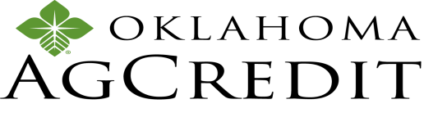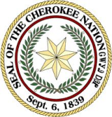

*Cherokee*

*Nation*





** Jim Rexwinkle

Gr een Country Ford Sodexo at NEO A&M

Afton Area Chamber Of Commerce appreciates Sponsorship & Cooperation of

Afton Area Business, School, & Organizations!

For more information call: 918-533-1063 or 918-533-4902